- Goal & Purpose

  - The goal of this grant program is to provide financial assistance to Emergency Communication Districts (ECDs) based on demonstrated need(s) in compliance with §11-98 et seq. of the Code of Alabama 1975, as amended. The purpose is to fund 911-related costs necessary to achieve or maintain continuity and enhancement of 911, assuring that every location in Alabama has access to 911 service.
  - Grant Cycle 10 will be entirely focused on NG911 call handling solutions (CHE) and NG911 recorder projects. All other project categories will not be considered and will be excluded from the Grant Cycle 10 evaluation.
  - The grant program will be funded to the extent that funds are available to the Alabama 9-1-1 Board in compliance with §11-98 et seq. of the Code of Alabama 1975, as amended and the administrative rules of the Alabama 9-1-1 Board.

- Eligibility

  - Eligible applicants:
    - Must be recognized as a validly formed Alabama ECD at the time of submission;
    - Must be in compliance with §11-98 et seq. of the Code of Alabama 1975, as amended;
    - Must be in compliance with the Alabama Statewide 9-1-1 Board Administrative Code
    - Must be willing and available to provide reasonable ECD and/or PSAP data at the Alabama 9-1-1 Board or its designee’s request.
    - Must have submitted an ECD certification for the grant cycle during which they are applying.
    - Must have submitted the annual reporting information required by the Department of Examiners of Public Accounts for the grant cycle during which they are applying.

- Definitions

  - The definitions stated in §11-98 will apply in addition to the following:
    - Grant cycle—the timeframe assigned in the calendar
    - Deliverable – item able to be provided as a product of the grant project process

- Calendar

  - The application period for Grant Cycle 10 will open on or before June 18, 2024; applications are due on August 9, 2024. Review of applications will take place during the months of August and September 2024 and grants will be recommended for award at the Alabama 9-1-1 Board meeting on September 18, 2024 if applicants have met the requirements of this grant cycle, inclusive of any additional or supplementary data required by the Board. Applicants may submit no more than one individual application per grant cycle.

- General Conditions

  - The applicant must provide an electronic version of the application package with any accompanying documentation to be emailed or placed on a storage media device to be mailed or hand delivered to the office of the Alabama 9-1-1 Board on or before August 9, 2024. Application materials need to be emailed to adam@al911board.com.
  - Procurement of hardware and/or software products and services shall be based on ECD’s governing authority’s purchasing requirements and any applicable State of Alabama purchasing requirements.
  - All grant applications for the purchase of hardware and/or software products and services shall be accompanied by at least two written competitive complete quotes from different vendors for grants requesting new equipment or services. If the applicant is unable to provide at least two quotes, include the reason(s) why.
  - The Alabama 9-1-1 Board or its designee will consider leasing of equipment assuming the applicant can show that leasing rather than purchasing will significantly reduce total costs. Leasing costs should be calculated to account for any introductory costs or included warranty and maintenance costs and any value-added upfront costs that may reduce the lease amount. If awarded, it will be the responsibility of the ECD to maintain and fund the lease beyond the grant award cycle.
  - If two or more ECDs choose to apply jointly for a grant, each ECD will be required to submit an individual “ECD Information” and “Financial” Sheets while the remainder of the grant application, i.e. the “Cover” and “Project Details” Sheets, will be required to be submitted jointly. All sheets of the grant application will be submitted as a single package detailing the entire project as well as a memorandum of understanding between all ECDs involved in the project.
  - Applications must include all necessary costs (including that of any third party) required for the full implementation of the project. If the grant application award is less than the total cost of the project, the applying ECD will be required to provide verification of their ability to fund the difference.

- Eligible Use of Funds

  - Grant funds must be used pursuant to §11-98-6, which outlines the disposition of funds (Appendix 11.1.1).
  - Any property acquired with grant funds must be used for the direct benefit of the ECD throughout the useful life of the property.

- Application Form

  - Applications must be typewritten and shall provide at a minimum the following information:
    - Application cover sheet (page 6 of this document)
    - ECD information sheet (page 7 of this document)
    - Financial sheet (page 8 of this document)
    - Project details (page 9 of this document)

- Review of Application

  - The decision to award or to not award grant funds is entirely at the discretion of the Alabama 9-1-1 Board or its designee.
  - The Alabama 9-1-1 Board or its designee will evaluate all complete and eligible applications submitted based on the substance of the request and make funding recommendations to the full Board.
  - The Alabama 9-1-1 Board or its designee will notify applicants within 30 days after receipt of the application if the application does not meet the guidelines and will identify the items that need to be provided before the application will be considered by the Alabama 9-1-1 Board or its designee.
  - It is important that applicants demonstrate that they have developed an attainable plan to achieve or maintain continuity and enhancement of 911 services. Priority will be given to those projects:
    - That require immediate funds to continue operation that may include, but is not limited to:
      - Bringing current any default on any indebtedness;
      - Being able to continue compensating 911 personnel’s wages and benefits;
      - Replacement, repair, or upgrade of a system critical to the provision of 911 service;
    - That implement measures that maximize efficiencies in the provision of 911 services in the State of Alabama that may include, but is not limited to:
      - Regionalization or consolidation of facilities, systems, etc.;
    - That enhance existing services or fill the technology needs of the ECD that will facilitate significant progress toward achieving readiness for and compatibility with next generation 9-1-1 technology systems that may include, but are not limited to:
      - Hardware and software for Call Handling Equipment (CHE);
        - All CHE hardware and software systems must adhere to the system service provider recommended CHE Connectivity Standards listed in Appendix 11.1.3.
      - Protective, enhancing, and backup systems, such as grounding/lightning protection, uninterruptable power supplies, NG911 GIS database and mapping enhancements, etc.
  - Applicants must compete against other applicants requesting funds and the Alabama
9-1-1 Board or its designee will award funds after considering, in no particular order, the following factors:
    - Soundness of project plan;
    - Feasibility of project;
    - Readiness to proceed;
    - Sustainability of the project without additional funding from the Alabama 9-1-1 Board; and
    - Degree to which grant funds will assist in achieving or maintaining compliance with any Board-adopted standards, policies, projects, missions, plans, objectives, or rules.
- Approval and Award

  - Within 60 days after the application deadline, the Alabama 9-1-1 Board or its designee will make a decision to either approve or disapprove each application. The Alabama
9-1-1 Board or its designee may choose to modify the amount of any grant awarded by either increasing or decreasing the amount requested in the application.
  - The Alabama 9-1-1 Board or its designee will notify each applicant in writing of the Alabama 9-1-1 Board or its designee’s decision on the application.

- Administrative/Reporting Requirements

  - Successful applicants must enter into a Grant Project Agreement with the Alabama 9-1-1 Board or its designee. The Grant Project Agreement will establish the terms and conditions of the grant award.
  - Successful applicants will be required to submit a Request for Change Form for approval prior to any project scope changes being made.
  - Successful applicants will be required to submit quarterly Status Reports during the project based on the terms and conditions laid out within the Grant Project Agreement.

- Appendices

    - Disposition of Funds
    - Application
    - ANGEN CHE Connectivity Standard
    - Sample Grant Project Agreement
    - Sample Request for Change
    - Sample Status Report

Please direct questions to:
Adam Brown
Deputy Director
Alabama 9-1-1 Board
By Postal Service: 1 Commerce Street, Suite 620, Montgomery, AL 36104
In person: 1 Commerce Street, Suite 620, Montgomery, AL 36104
By phone: 334-440-7911
By email: adam@al911board.com

Submit Applications to:
Office of the Alabama 9-1-1 Board
Attn: Grant Program Application – Cycle 10
Email: adam@al911board.com
By Postal Service: 1 Commerce Street, Suite 620, Montgomery, AL 36104
In person: 1 Commerce Street, Suite 620, Montgomery, AL 36104

Section 11-98-6

Disposition of funds.
(a) Funds received by a district pursuant to Section 11-98-5.2 shall be used to establish, operate, maintain, and replace an emergency communication system that, without limitation, may consist of the following:
(1) Telephone communications equipment to be used in answering, transferring, and dispatching public emergency telephone calls originated by persons within the service area who dial 9-1-1.
(2) Emergency radio communications equipment and facilities necessary to transmit and receive dispatch calls.
(3) The engineering, installation, and recurring costs necessary to implement, operate, and maintain an emergency communication system.
(4) Facilities to house E-911 operators and related services as defined in this chapter, with the approval of the creating authority, and for necessary emergency and uninterruptable power supplies for the systems.
(5) Administrative and other costs related to subdivisions (1) to (4), inclusive.
(b) A district or county or municipal governing body may receive federal, state, county, or municipal real or personal property and funds, as well as real or personal property and funds from private sources, and may expend the funds or use the property for the purposes of this chapter.
(c) Subject to the remaining provisions of this chapter and the approval of the 9-1-1 Board and the creating authority, two or more districts, cities, or counties, or a city and a county in another district may agree to cooperate, to the extent practicable, to provide funding and service to their respective areas, and a single board of commissioners of not more than seven members may be appointed to conduct the affairs of the entities involved. In the event that two or more districts are consolidated for purposes of this chapter, the base distribution amount as defined in Section 11-98-5.2 (b)(3) shall include the combined base distribution amounts that would have been calculated for the individual districts.
(d) Subject to rules that may be adopted by the 9-1-1 Board, a district may expend available funds to establish a common address and location identification program and to establish the emergency service number data base to facilitate efficient operation of the system. The governing body and the E-911 Board of each county or city affected shall be jointly responsible for purchasing and installing the necessary signs to properly identify all roads and streets in the district.
(e) Beginning with fiscal year 2013, the Department of Examiners of Public Accounts shall audit each district on a biennial basis to ensure compliance with the requirements of this chapter regarding both revenues and expenditures.
(Acts 1984, No. 84-369, p. 854, §5; Acts 1992, No. 92-562, p. 1165, §1; Act 98-338, p. 584, §1; Act 2007-459, p. 950, §1; Act 2012-293, p. 592, §1.)

Cover Sheet

Emergency Communication District (ECD) Name:
Click here to enter text.

Total Grant Amount Requested:
Click here to enter text.

Project Title:
Click here to enter text.

ECD’s 9-1-1 Board Chair
Name: Click here to enter text.
Mailing Address: Click here to enter text.
Phone: Primary- Click here to enter text.
Secondary-Click here to enter text.
Fax-Click here to enter text.
Email: Primary- Click here to enter text.
Secondary-Click here to enter text.

ECD’s 9-1-1 Coordinator/Director/Representative
Name: Click here to enter text.
Job Title: Click here to enter text.
Mailing Address: Click here to enter text.
Phone: Primary- Click here to enter text.
Secondary-Click here to enter text.
Fax-Click here to enter text.
Email: Primary- Click here to enter text.
Secondary-Click here to enter text.

Federal Tax ID Number:
Click here to enter text.

ECD Information Sheet

Emergency Communication District (ECD) Name:
Click here to enter text.
Project Title:
Click here to enter text.
County:
Click here to enter text.
Population served:
Click here to enter text.
Annual number of 911 calls (the preferred source of this information would be from the ECD’s call handling solution analytics package):
Click here to enter text.
Organizational chart:
Click here to enter text or insert an image below.

Description of ECD’s existing equipment and operations:
Click here to enter text.
Number of 911 Call-taking positions:
Click here to enter text.

Upon receipt of application, the Alabama 9-1-1 Board or its designee may provide the applying ECD with data that is on file within its office for verification.

Financial Sheet

Emergency Communication District (ECD) Name:
Click here to enter text.
Project Title:
Click here to enter text.
- Provide an itemized budget for the proposed grant project.

- For hardware and/or software or services, provide at least two written competitive complete quotes. If the product or service is on state contact or part of an approved cooperative purchasing list, two quotes are not required. If the applicant is unable to provide at least two quotes, include the reason(s) why.

- Provide a copy of applying ECD’s approved FY2024 budget.

- Provide a copy of applying ECD’s Department of Examiners of Public Accounts Districts Annual Required Reporting Form (which was required by the Department of Examiners of Public Accounts be submitted by each ECD no later than November 30th, 2023)

Project Details

Emergency Communication District (ECD) Name:
Click here to enter text.
Project Title:
Click here to enter text.
Provide a type-written plan using 12-point font that outlines the following components of the proposed grant project. Be specific and include the following components.
- Statement of need (Limit your submission to no more than one page.)
  - Justification for project
  - Impact on operational services
  - Consequences of not receiving funding
  - Availability or lack of other funding sources
  - Sustainability of project by ECD
Click here to enter text.
- Scope of work (Limit your submission to no more than one page.)
  - Goals
  - Objectives
  - Tasks to be performed
  - Deliverables
Click here to enter text.
- Schedule (Limit your submission to no more than one page.)
Click here to enter text.
- Any other information that the applying ECD deems relevant to consider in the decision-making process (Limit your submission to no more than one page.)
Click here to enter text.

The document provides a high-level overview for planning call handling systems, detailing how cloud-based, data center-based, and premise-based systems connect with the Alabama Next Generation Emergency Network (ANGEN), the call delivery network contracted by the Alabama 9-1-1 Board (Board). As ANGEN’s system service provider, INdigital recommends this connectivity framework when implementing call-handling applications. The goal is to provide a Public Safety Answering Point (PSAP) and its call handling system (CHS) provider with reliable opportunities to utilize the ANGEN network. No matter the deployment strategy, it will be imperative to test call handling failover and work through a call delivery test plan in coordination with the Board and INdigital.
Cloud-Based Call Handling
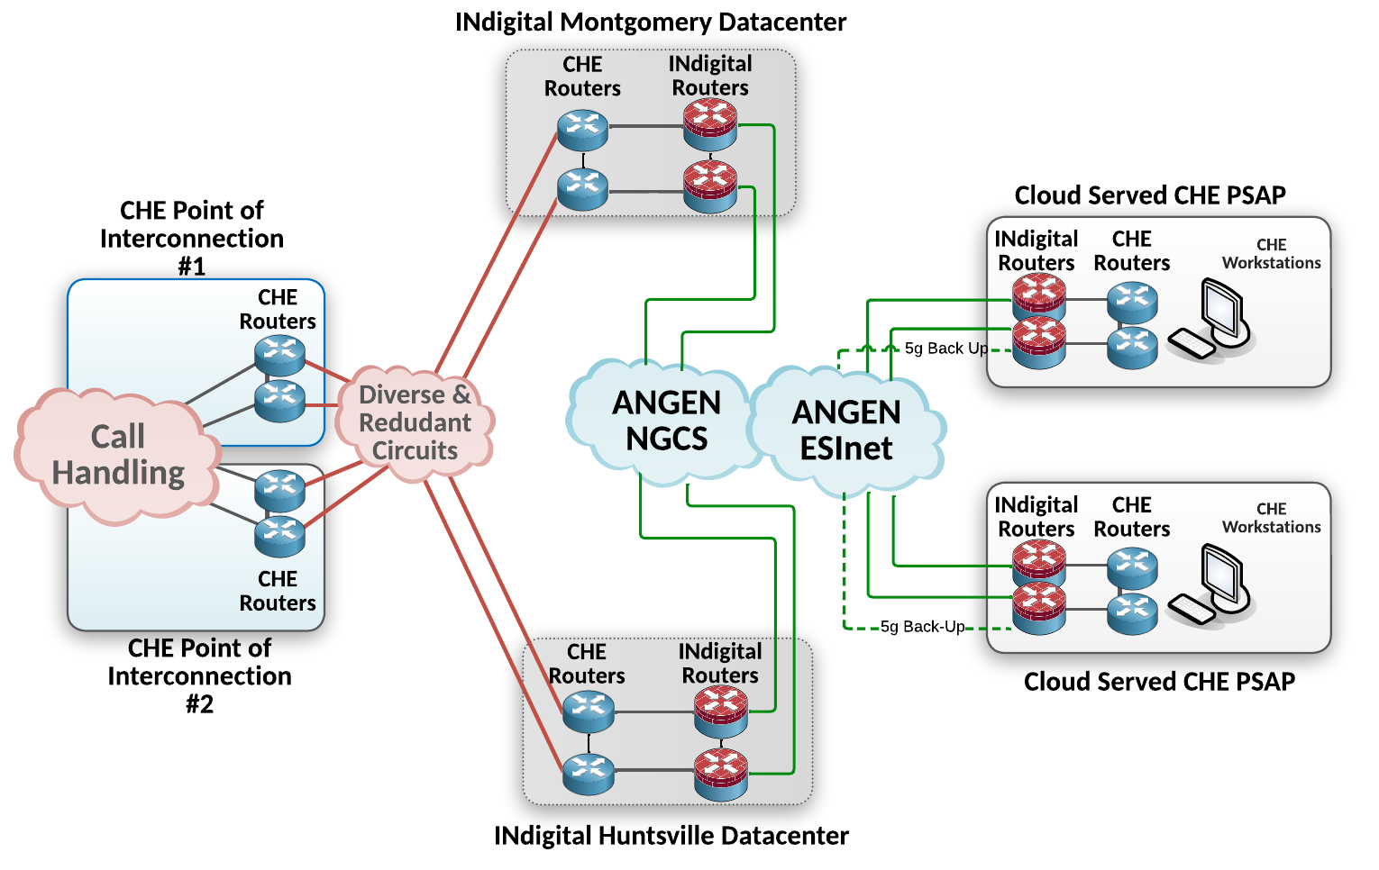
This diagram emphasizes the multiple redundant pathways for connectivity, both into and out of ANGEN’s data centers to the PSAPs, particularly focusing on cloud-based call handling systems. Connectivity paths extend from these data centers, illustrating the diverse redundant routes for connecting each cloud-based service into and out of ANGEN’s data centers to the PSAPs. ANGEN’s primary goal in this model is to utilize redundant and carrier-diverse connections from ANGEN’s data centers to the PSAP.

Call Handling System providers must share bandwidth requirements with INdigital before deployment. Not all PSAPs on ANGEN have the same network connectivity availability as others. The Board and INdigital will work with the project stakeholders to achieve a successful outcome.

Data Center-Housed or Hosted Call Handling
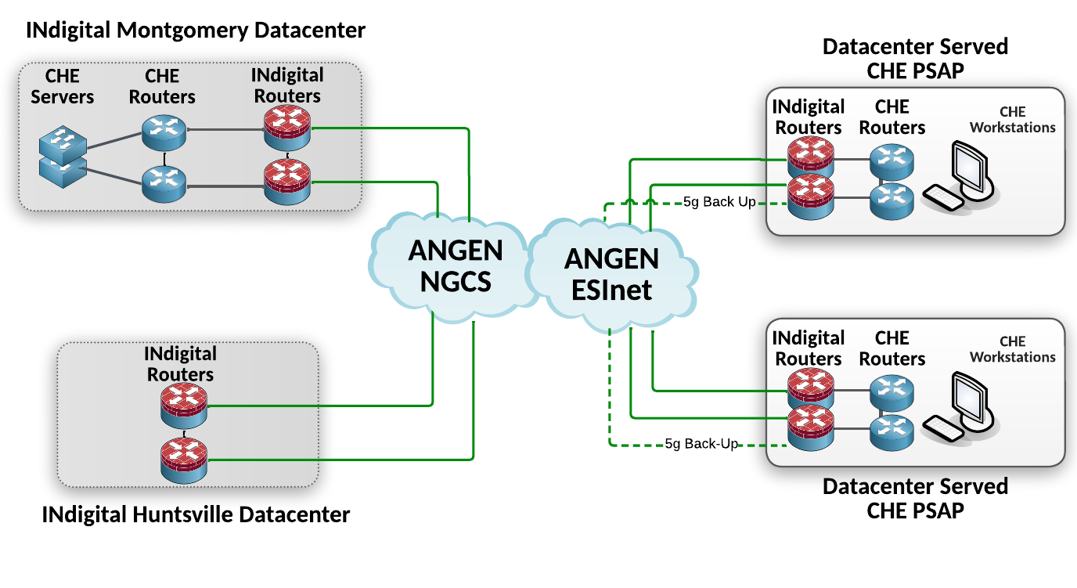
This diagram underscores the redundant pathways from ANGEN’s data centers to the PSAPs, specifically focusing on data center-housed call handling systems. Connectivity paths extend from these data centers, demonstrating the array of redundant routes available for linking each data center-based service out of ANGEN’s data centers to the PSAPs.
*In this arrangement, Call Handling Equipment (CHE) controllers are housed in one data center, with ANGEN’s ESInet and MEVO providing call path redundancy. Alternatively, CHE controllers can be housed in both data centers. However, further discovery would need to be done concerning how the specific CHE uses the network in a failover and reconvergence capacity as well as bandwidth requirements before deployment.

Premise-Based Call Handling

This diagram highlights the redundant pathways from ANGEN’s data centers to the PSAPs, specifically emphasizing premise-based call handling systems. Connectivity paths extend from these data centers, showcasing the redundant routes accessible for linking each premise-based service out of ANGEN’s data centers to the PSAPs. ANGEN supports transitional i3 and full i3. Schedule a call with INdigital and/or ANGEN representatives to discuss any specifics needed to operate the system.

Sample Agreement

Emergency Communication District (ECD) Name:
Sample Emergency Communication District
Project Title:
911 Grant Project
Grant Number:
GC-0000-000
The following will be formulated based on the project awarded according to the advice of the Alabama 9-1-1 Board’s General Counsel.
- Notification of award
- Terms and conditions
- Any disclaimers

Sample Grant Project Request for Change

Emergency Communication District (ECD) Name:
Sample Emergency Communication District
Project Title:
911 Grant Project
Grant Number:
GC-0000-000
Date:
01/01/1999
Provide a description of the planned change. (Limit your submission to no more than one page.)
The project change description is listed here.
Provide justification for change. (Limit your submission to no more than one page.)
The reason for requesting the project change is listed here.

☐ Approved
☐ Not approved
Reason(s) for disapproval.

Sample Grant Project Status Report

Emergency Communication District (ECD) Name:
Sample Emergency Communication District
Project Title:
911 Grant Project
Grant Number:
GC-0000-000
Date:
01/01/1999
Provide a project status update. (Limit your submission to no more than one page.)
The project status is listed here.
Provide a description of any changes, problems, delays/advances, etc. impacting the initial timeline submitted for the project. (Limit your submission to no more than one page.)
Any further description of changes, problems, or other delays/advances impacting the timeline are listed here.

